HCAA JH State Basketball
Playoff T-Shirt

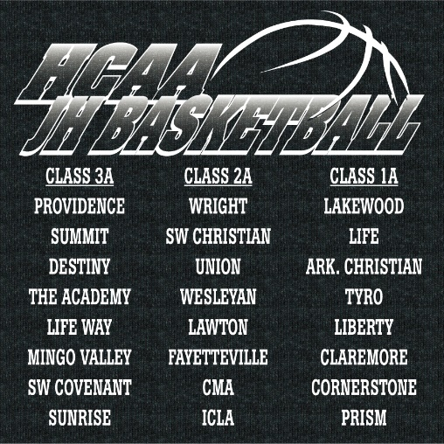
(Front of Shirt) (School names will be listed on the back of the shirt)

Name: __________________________ Phone: ______________________________
School: _________________________
ORDERS ARE DUE: Junior High – Tuesday, Jan. 22nd
Write the quantity of shirts per size you are ordering:
Short Sleeve ($15.00):
Youth Large ____ Adult Small ____ Adult Medium ____
Adult Large ____ Adult XL ____ 2XL _____ 3XL ____
Long Sleeve ($25.00):
Youth Large ____ Adult Small ____ Adult Medium ____
Adult Large ____ Adult XL ____ 2XL _____ 3XL ____

Make checks payable to HCAA.
Please email your shirt sizes to Chris Hamel at clhamel@gmail.com.
JH Shirts will be available to pick up at your game at the State Tournament.
HS Shirts will be available to pick up at the Regionals.

